Editing Your First Super Mario Bros. 3 Level in Super Mario All-Stars
By DrAnas

1. Introduction
Hello there! My name is DrAnas and this will be a straightforward tutorial on how exactly to edit your levels in the Super Mario All-Stars version of Super Mario Bros. 3. But before we get into that, why not take a glance back at the history of SMAS SMB3 hacking?

You see, not many people know this, but the very first known SMAS SMB3 hack was released sometime in early 2004 or earlier by a Japanese Super Mario World hacker named KT, which some SMW hackers might be familiar with. At around the same year or later, a guy named Insectduel started SMAS SMB3 hacking and made a hack named ‘Super Mario Bros. 3: The Lost Levels’; however, this hack doesn’t seem to be available anywhere anymore. He’s gone on to become possibly the most prominent SMAS SMB3 hacker on the internet as of now!

Then, in 2008, some prominent SMW hackers from SMW Central such as Ersanio, spel werdz rite (a.k.a. SWR), and Roy proposed disassembling the entirety of the SMAS code and documented lots of it over the years. But this isn’t the only disassembly effort, because Yoshifanatic1, another SMWC member, starting disassembling SMAS sometime in early 2018 and first released it in 2019, although he’s refined it over the years.
Unfortunately, despite all of these efforts, there’s no direct editor for SMAS SMB3 in the slightest! So far, virtually all of the levels & hacks that you can see on the internet were painstakingly hex-edited, and normally this would put many beginners off because of how much data must be manually tracked down within the static ROM, but where there’s a will, there’s a way, and right now, it’ll become far easier than before! Until a new editor surfaces out of the horizon, these are the tools we will need to efficiently edit your levels…
2. Tools Required
- A clean, unheadered American Super Mario All-Stars + World .sfc ROM
- A clean American Super Mario Bros. 3 .nes ROM (can be Rev. 1.0 or 1.1)
- My Linux-compatible fork of Yoshifanatic’s SMAS+W disassembly
- SMB3 Foundry & Scribe (supports Linux too!)
- A good hex editor that supports Linux, such as ImHex
- And of course, an emulator than can directly play both SNES and NES games, such as MesenCE!

3. Preparing Your Standalone SMAS SMB3 ROM
Did you know that thanks to YF’s disassembly, you can compile a standalone SMAS SMB3 ROM from scratch? This is excellent, especially since most of you might only care about hacking SMB3 and not the other games. Here’s the steps…

1. First, download my fork & drag the whole 'SMW-SMAS-SMASW-Disassembly-main' folder somewhere you like.
2. Rename your SMAS+W ROM to 'SMAS.sfc' and drag it to 'SMAS/AsarScripts'.
3. Skip to step 4 if you’re on Windows! If on Linux, go to the 'Global' folder and right-click on the file 'Asar'. Under 'Properties/Permissions', enable 'Allow executing file as program'.
4. To extract the ROM’s assets, while in ‘AsarScripts’, either click on ‘ExtractAssets.bat’ if on Windows, or open the Linux terminal, and do 'bash extract_assets_linux.sh' if on Linux.
5. You’ll be prompted to select what type of ROM your SMAS+W ROM is, and since it’s American, select the ‘SMAS+W (USA)’ option. All of the game’s assets will now be extracted in their respective places!

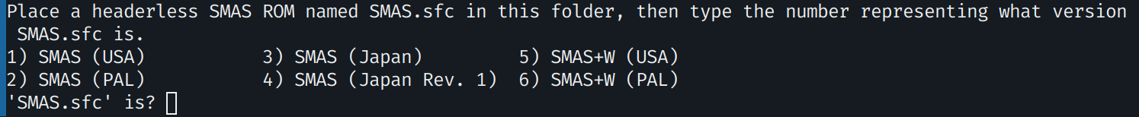
The Linux version of the asset-extracting prompt

6. Now go to ‘SMB3/RomMap/ROM_Map_SMB3_U.asm’ and set a particular define named ‘!Define_Global_IgnoreOriginalFreespace’ to ‘!TRUE’. Otherwise, if your level data is even slightly bigger than the original, the ROM may fail to assemble and thus won’t be playable!
7. Finally, go to the ‘SMB3’ folder and there, either click on ‘Assemble_SMB3.bat’ if you’re on Windows, or open the terminal again and do 'bash assemble_smb3_linux.sh' if you’re on Linux.

The Linux version of the ROM-assembling prompt

7. If done correctly, a fully-playable standalone ROM called 'Super Mario Bros. 3 U.sfc' will be created! To reassemble, go back to step 6!

4. Editing Your NES SMB3 Level
Even if you’re already super familiar with Foundry, I believe it’s quite important for you to read thru a lot of this section to avoid confusion.

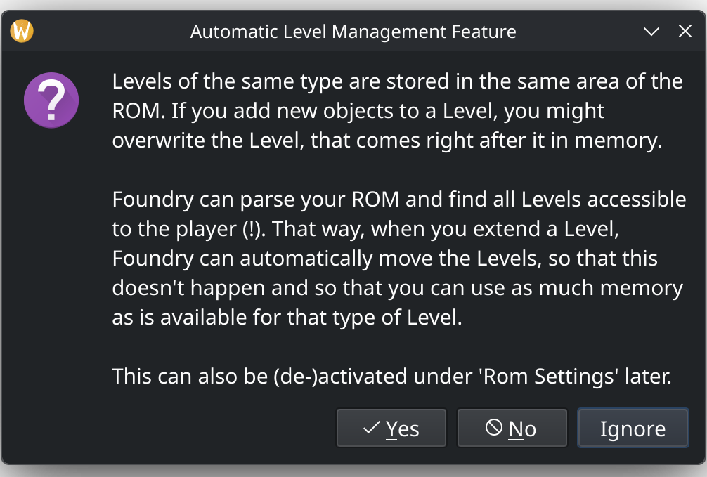
Firstly, open your NES ROM SMB3 Foundry & click ‘Yes’ on the prompt about the editor being able to automatically allocate more space for your levels as the ROM allows.

Also, to avoid annoying crashes particularly on Linux, go to ‘File/Settings’ & disable the option ‘Ask if Backup should be restored, after crash’. This might be fixed in the future, but still.
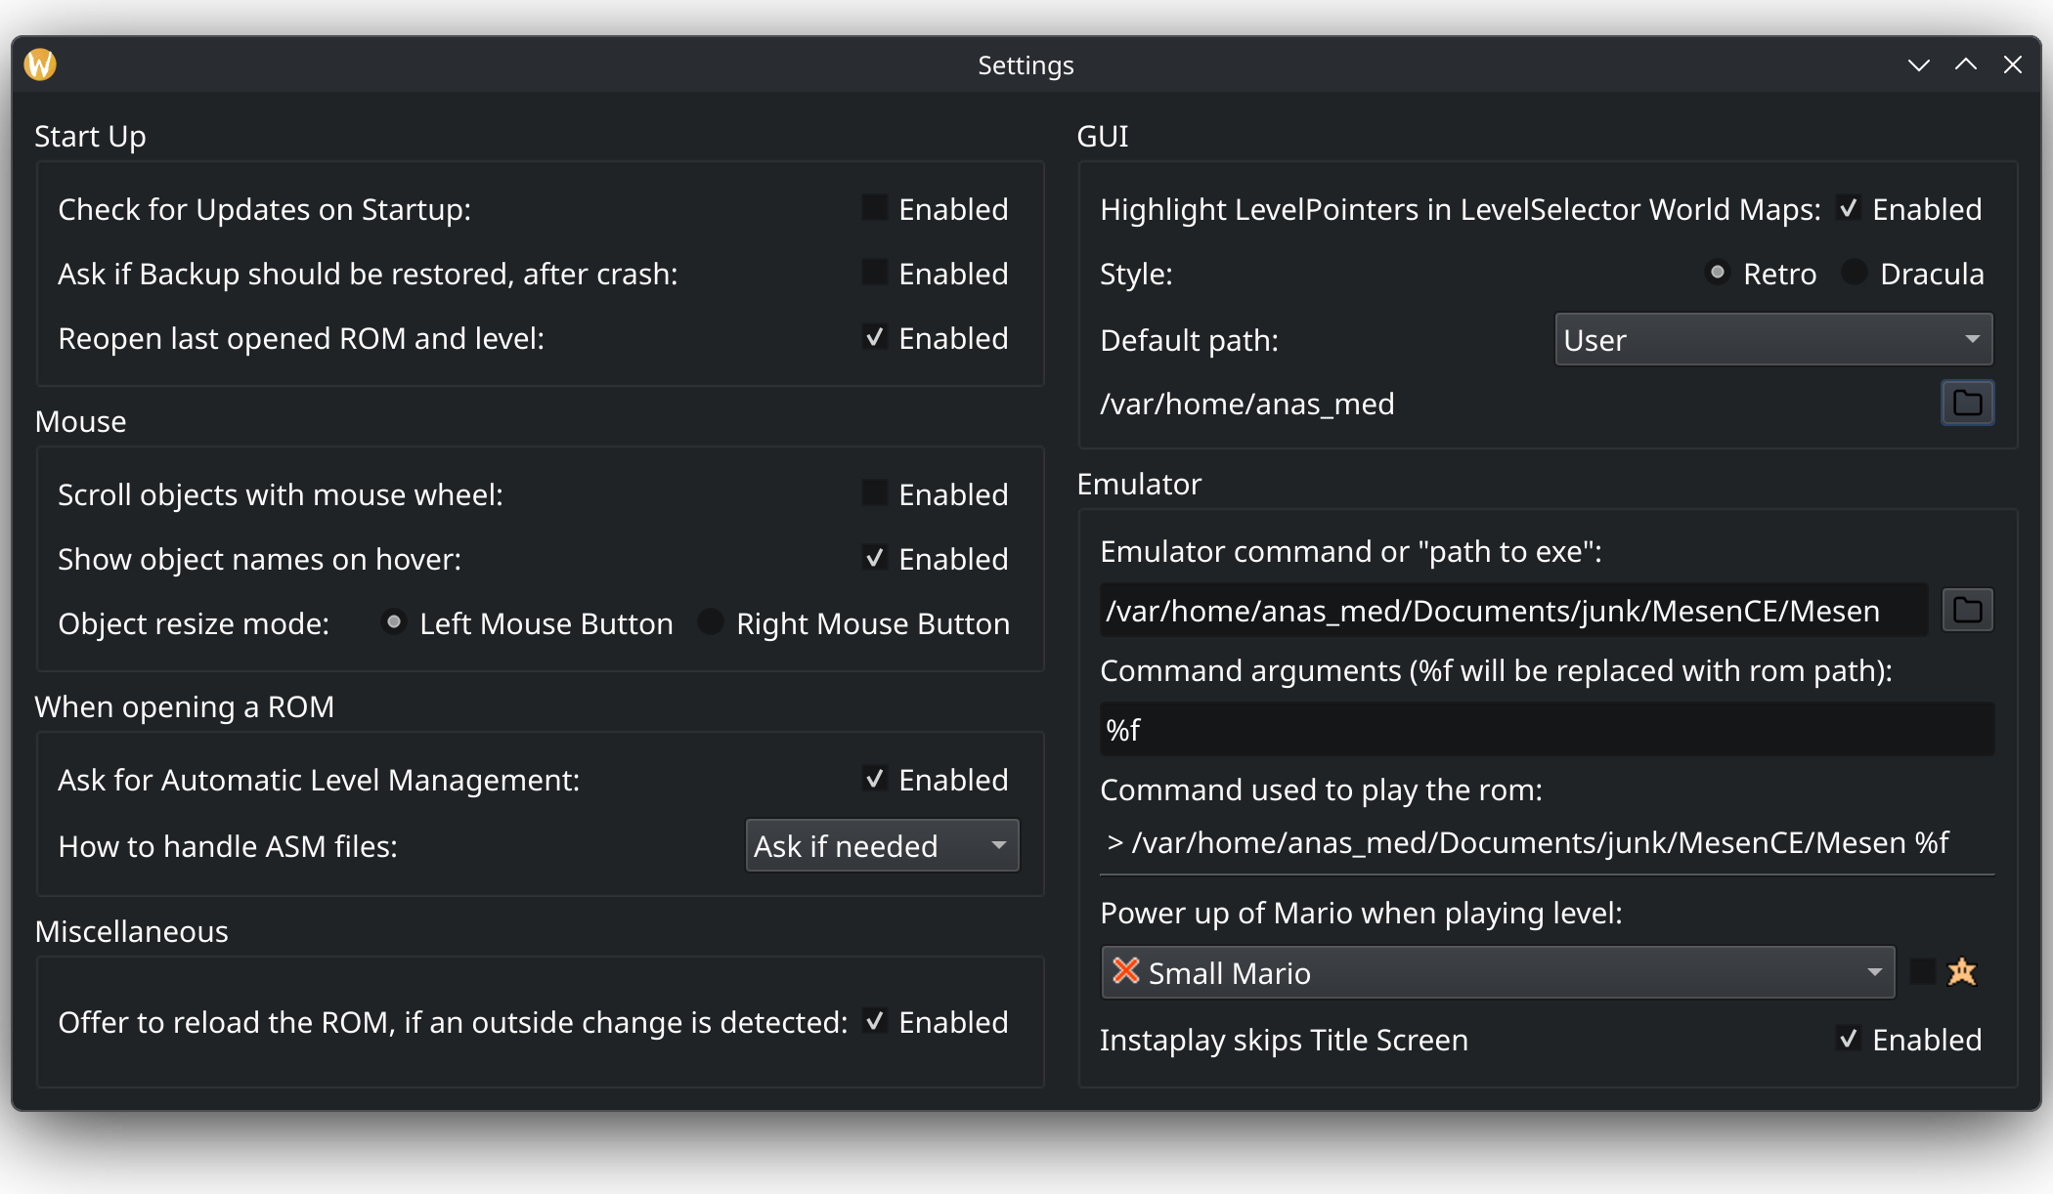

Afterwards, you should automatically boot up in level 1-1, which is actually what we’re gonna work with. To access other levels at any time, go to ‘Level/Select New Level’ and it’ll show previews of all of the ROM’s overworlds, as shown down below. You can select any appropriate level tile and edit the level there.

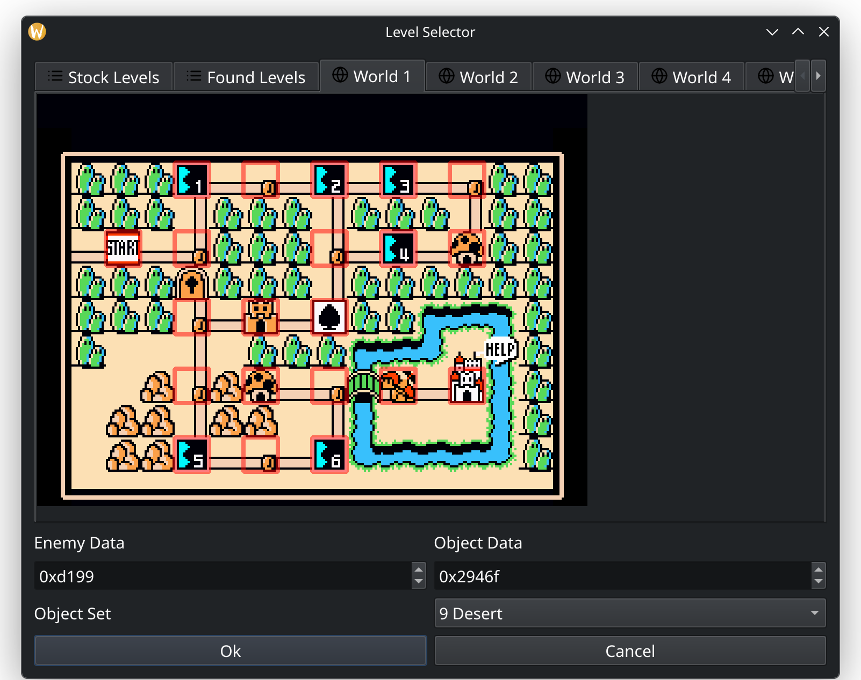
Anyways, now that we’re in 1-1, let’s go ahead and clear the original level data by doing ‘Ctrl+A’, then ‘Del’. Furthermore, look at the bottom-right corner with all the jump destinations. It should show ‘Jump to screen #8’, which you must delete, otherwise the editor will throw an error and you can’t save anything.
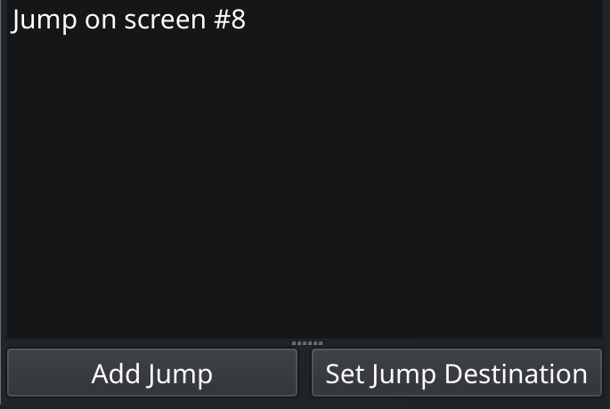

Finally, click ‘Set Jump Destination’ & then ‘Use current Level’.

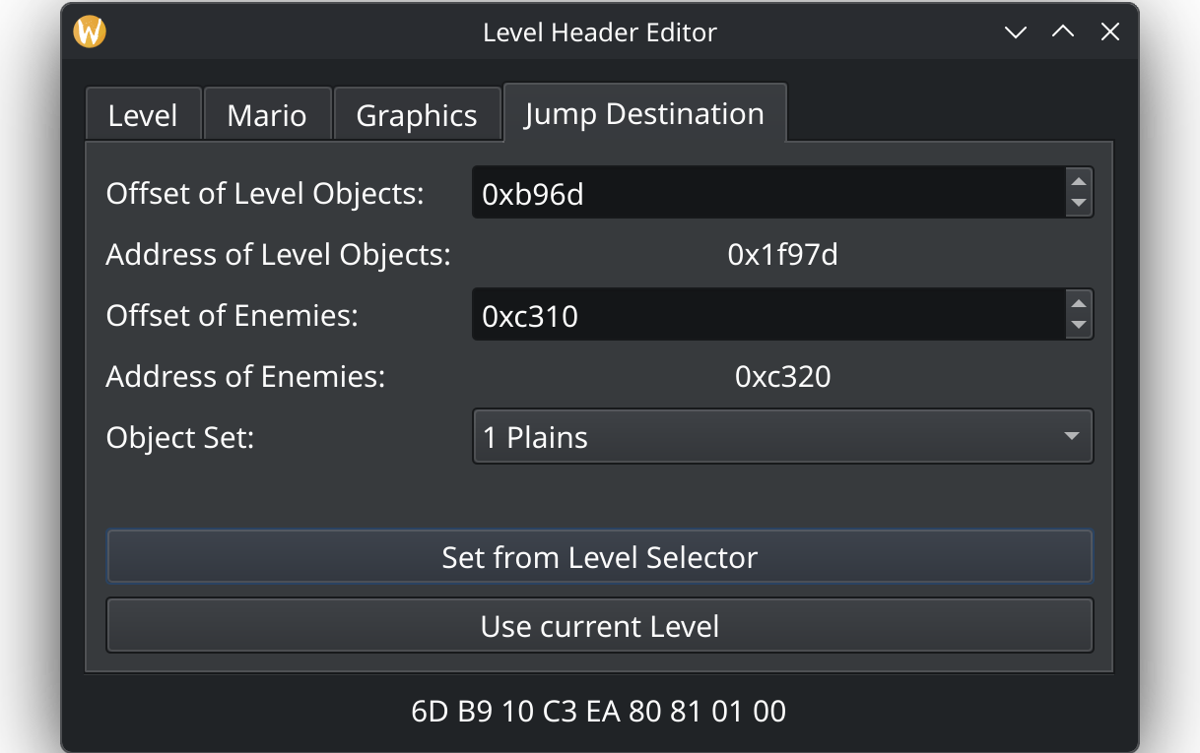

If done correctly, you should now be able to save your level!

As for actually designing your level… take some time to get used to the GUI and experiment! Most of it should be relatively self-explanatory, and you might quickly enjoy the experimentation! Don’t forget to test your level out on your emu of choice!

Our example level shall look like this...

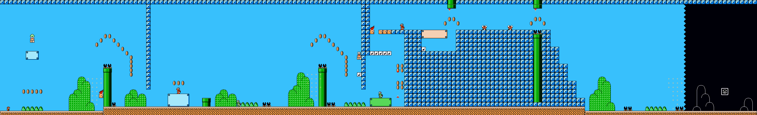

5. The SMAS Fun Begins…
Now that you’ve gotten used to Foundry, go ahead and save your level as an M3L by going to ‘File/Level/Save M3L’. When you open it in your hex editor, you’ll wonder what all the hex junk translates to. Why don’t we break it down?

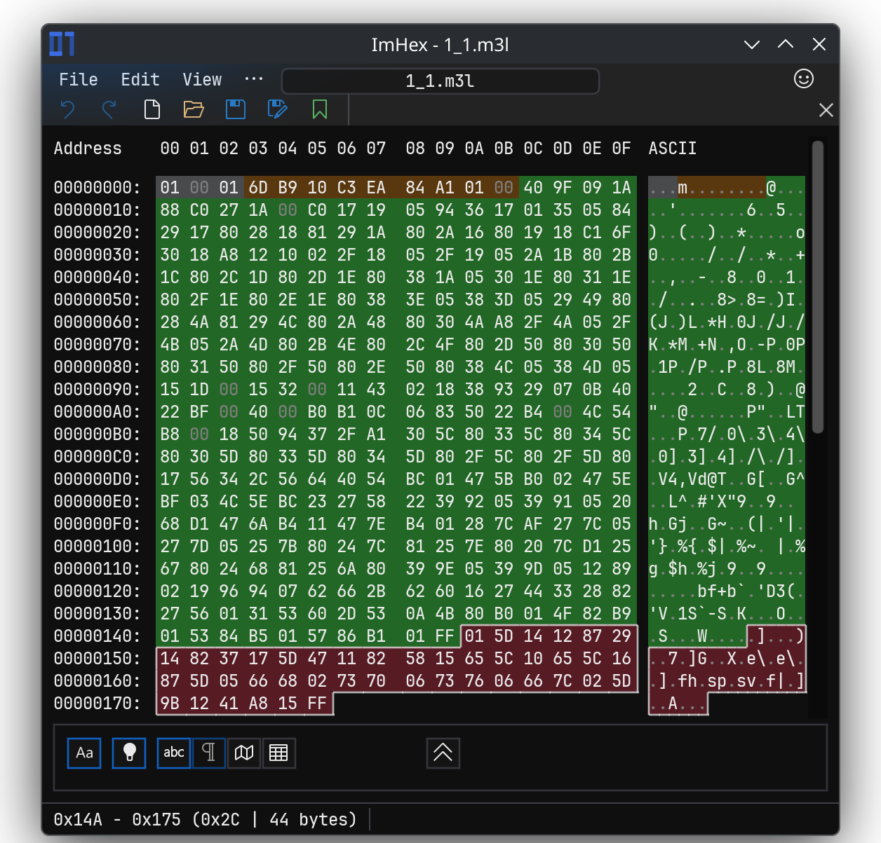

The M3L data of our example level in ImHex

Offsets 0x0-0x2: Unfortunately I couldn’t find any documentation about these bytes in the context of Foundry, but they don’t matter for us.
Offsets 0x3-0xB: This is the 9-byte level header of your NES SMB3 level. You can ignore it for now…
Level Object Data: Always starts right at offset 0xC & ends at byte 0xFF. This is the data of your level that contains all the objects (i.e., ledges, ?-blocks…) that you’ve placed.
Level Sprite Data: The starting point heavily varies based on where the object data ends, but also always ends at byte 0xFF. This is the data of your level that contains all of the sprites (i.e., enemies, items, platforms…) that you’ve placed.
Now that we’ve covered that, onto the SNES side! The awesome thing about YF’s SMAS disassembly is that all level object & sprite data is split into separate files, facilitating organization. Not to mention, since the disassembly will automatically ignore the hardcoded sublevel object & data pointers and dynamically allocate them, you don’t have to manually keep track of any offsets in the slightest! Finally, since it’ll also dynamically move the level data wherever ROM space allows, you’re not restricted to the original object & sprite data sizes and thus, your own level data can be much bigger! (as long as ROM space allows for it, of course)

You can find the files in ‘SMB3/Levels'. Any file with ‘_Level’ in the middle of its name contains the object data for the level, whereas any file with ‘_Sprite’ instead contains the sprite data. Moreover, if it ends in ‘_Main’, then it’s the main room of the level, and if it ends in ‘_Sub’, then it’s the relevant sublevel.
Since we wanna edit 1-1, we must navigate to the ‘World1’ folder & edit the relevant files ‘1-1_Level_Main.bin‘ & ‘1-1_Sprite_Main.bin‘. First, let’s open ‘1-1_Level_Main.bin‘ and break it down…
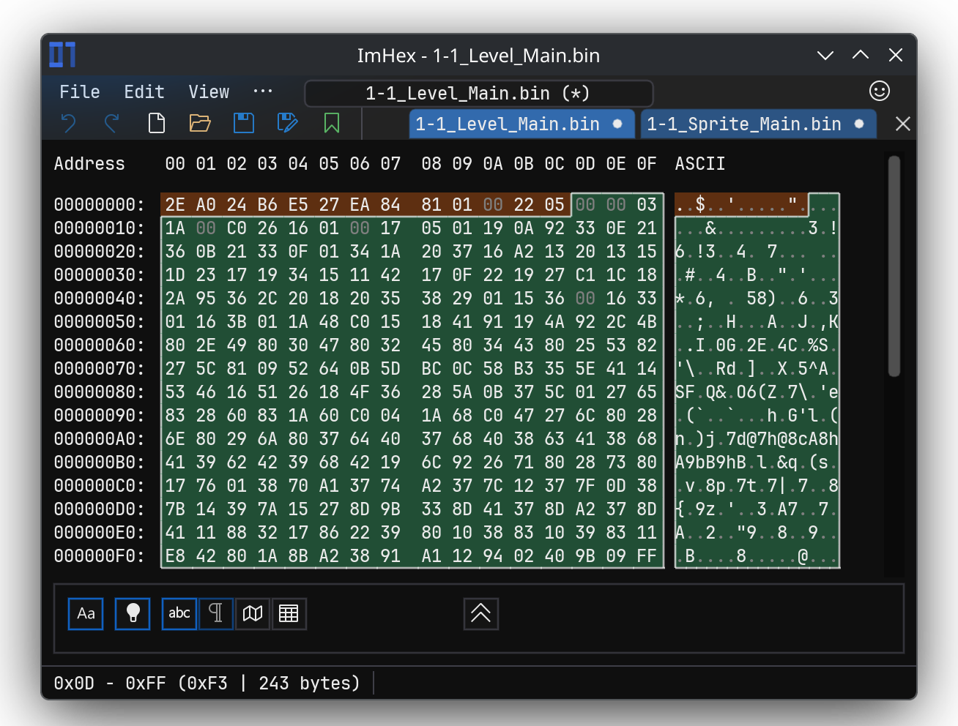

The level object data of the original SMAS SMB3 1-1 in ImHex
Offsets 0x0-0xC: This is the 13-byte level header of your SMAS SMB3 level. It’s vastly different from the NES one, and we will cover all 13 bytes later.
Level Object Data: Always starts right at offset 0xD & ends at byte 0xFF. It’s virtually the same format as the NES counterpart.
Now onto ‘1-1_Sprite_Main.bin‘…
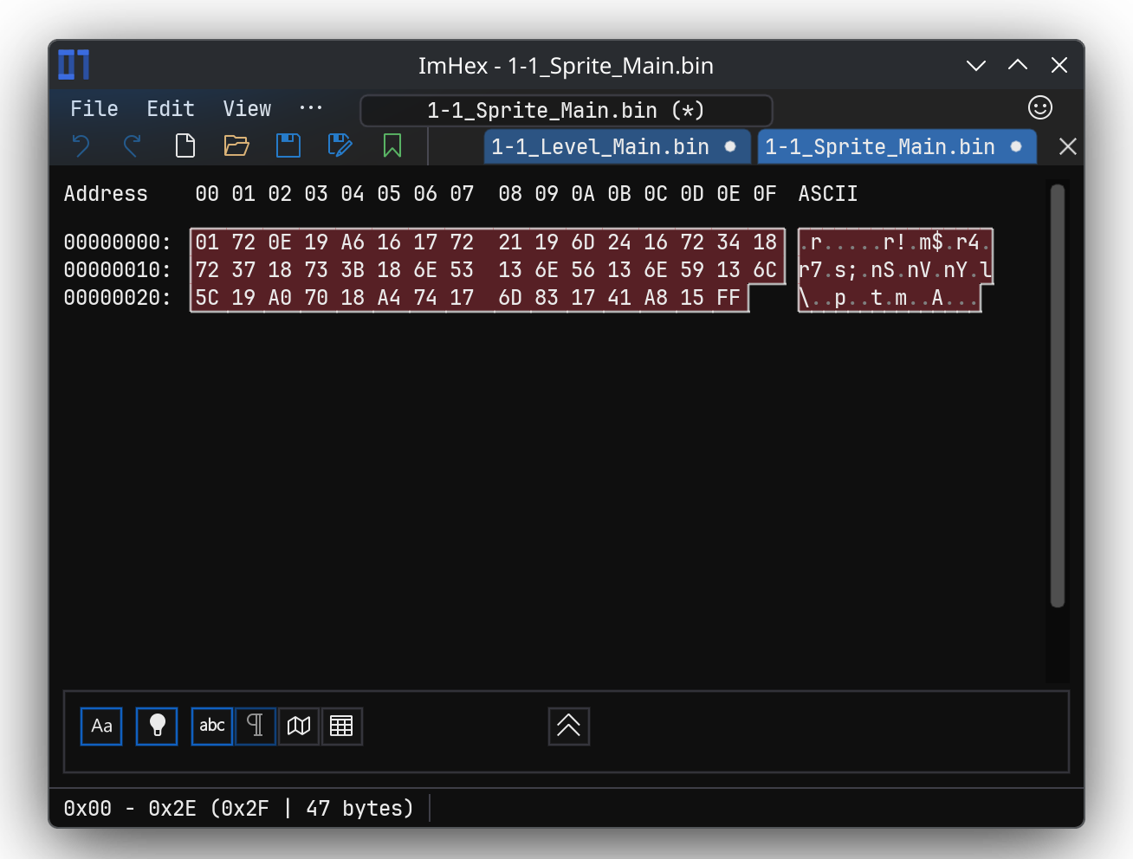

The level sprite data of the original SMAS SMB3 1-1 in ImHex
Level Sprite Data: Always starts at offset 0x0 since it’s separate from the object data & ends at byte 0xFF. It’s virtually the same format as the NES counterpart.

